Legacy theming with bslib and thematic

## R Markdown

This is an R Markdown document themed with [{bslib} package](https://rstudio.github.io/bslib/). {bslib} makes it easy to customize the main colors and fonts of a html_document, [flexdashboard::flex_dashboard](https://flexdashboard-pkg.netlify.app/articles/articles/theme.html), [shiny::fluidPage()](https://shiny.rstudio.com/reference/shiny/latest/fluidPage.html), or more generally any website that uses [Bootstrap](https://getbootstrap.com/) for styling. The theme parameter in the yaml front-matter of this Rmd document describes a [bslib::bs_theme()](https://rstudio.github.io/bslib/reference/bs_theme.html) object. This particular example uses Bootstrap 3 (version: 3), which is primarily for ‘legacy’ documents that would break with Bootstrap 4 or above.

## Themed Plots

When running this document with [{thematic}](https://rstudio.github.io/thematic/) installed, the thematic::thematic_rmd(font = "auto") effectively translates theme (CSS) settings to new global theming defaults for {ggplot2}, {lattice}, and {base} R graphics:

### ggplot2

library(ggplot2)  
  
ggplot(mpg, aes(displ, hwy)) +  
 geom_point() + geom_smooth()

## Error : The fig.showtext code chunk option must be TRUE

## `geom_smooth()` using method = 'loess' and formula = 'y ~ x'

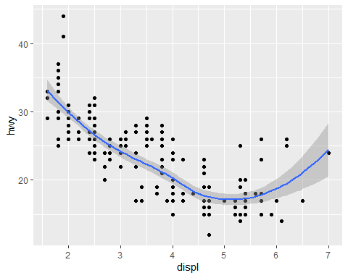

### lattice

lattice::show.settings()

## Error : The fig.showtext code chunk option must be TRUE

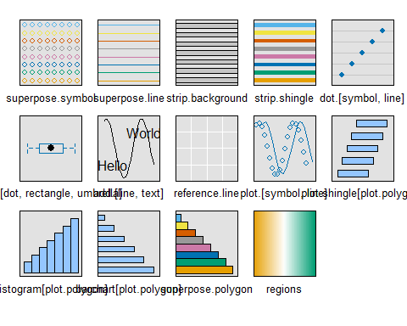

### base

plot(pressure, col = thematic::thematic_get_option("accent"))

## Error : The fig.showtext code chunk option must be TRUE

